**Birla Institute of Technology & Science, Pilani**

**Work-Integrated Learning Programmes Division**

**Mid Semester Examination**

Course No. : DSECL ZG557

*No. of Questions = 3*

Course Title : Artificial & Computational Intelligence

Nature of Exam : Open Book

Weightage : 30%

Duration : 1.5 Hours

Date of Exam : 08 / 11 / 2020, AN Time of Exam: 2:00 PM to 3:30 PM

**Key**

**Question -1 [2+4+2+2 =10 M]**

(1-a) Justify the statement “physical simulation of a person is unnecessary for intelligence” relating with an example intelligent system.

**Intelligent applications like weather forecasting, video recommendation, path finding and many more doesn’t not need a physical simulation like a person**

(1-b) Although natural language processing, knowledge representation, automated reasoning, and machine learning are the minimum required capabilities to clear the Turing's test. Predict the possible snags exhibited by AI system in the absence of each one of these capabilities. Give examples highlighting the need of each capability.

**With the absence of NLP, the system cannot understand the conversation**

**With the absence of KR, the system cannot store and remember facts, may ask the same questions repeatedly**

**The absence of automated reasoning may trouble the system in responding appropriately**

**The absence of Machine Learning capability does not much trouble the system to clear Turing’s test.**

(1-c) Construct a flow diagram for an AI system designed to participate in the Turing's test highlighting the I/O between the four software components each functioning a required capability

**AR**

**ML**

**KR**

**NLP**

(1-d) Name a popular AI system and its category. State and justify whether that category of AI systems can Think Humanly or Act Humanly.

Alexa under the category chatbot as a blackbox seems to be thinking humanly

For further details on Q.No: 1 contact Prof. Saikishor Jangiti

**Question -2 [ 8+2 =10 M]**

(2-a) Find the order of traversal of states from C to L using

1. Breadth-first search

**C, B,T,O,P,A,R,I,N,L**

1. Depth-first search

**C,B,A,R,T,O,I,N,P,L**

1. Uniform cost search

**C,T,O,P,B,A,R,L**

1. Iterative deepening search

**C, B,T,O,P,A,R,I,N,L**

(2-b) which one of the above search techniques is effective.

**Uniform Cost Search**

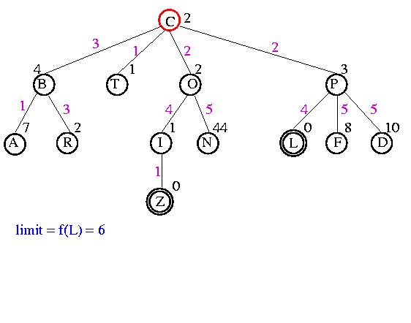

**Question -3 [2+4+4 =10 M]**

(3-a) Consider the A* tree search with f(n)=(2+x).g(n) + (x2).h(n) where g(n) is the cost from the start state n to the goal state. Find the integer values of x for which the algorithm is guaranteed to give the optimal solution.

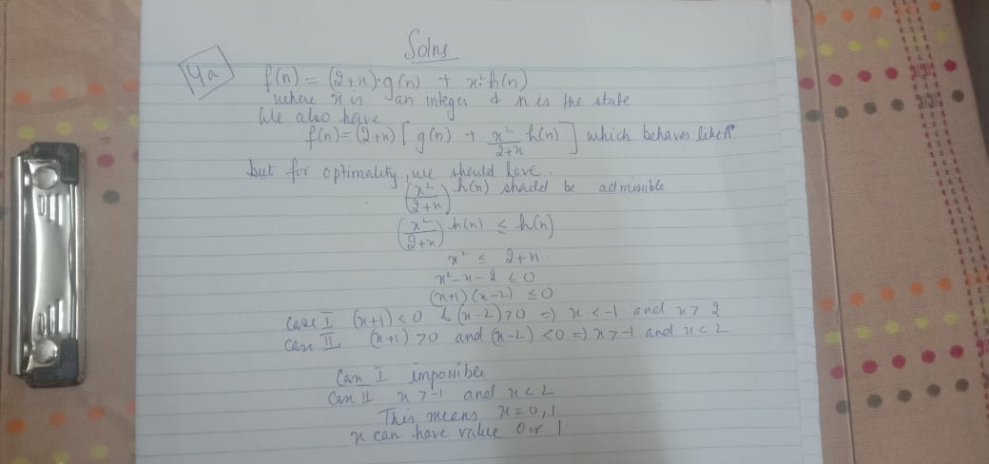

(3-b) Consider an infinite search space Z x Z. The start state is (0,0) and the goal state is at (GX, Gy). Given that the agent can move from a state (x, y) to either of (x+1, y), (x-1, y), (x, y+1) and (x, y-1) with a unit step cost, find the number of nodes explored using A* tree with Manhattan distance heuristic for (GX, Gy)=(4,5). Also give state space representation. Assume no duplicate detection.

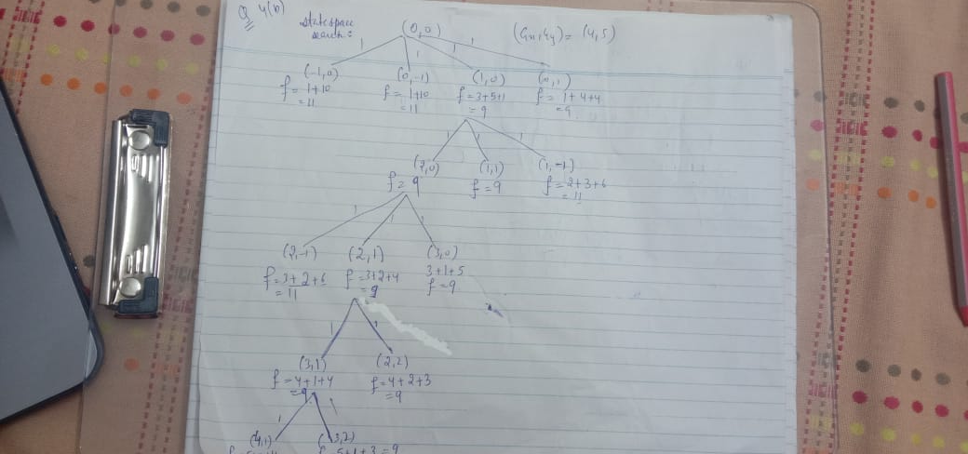

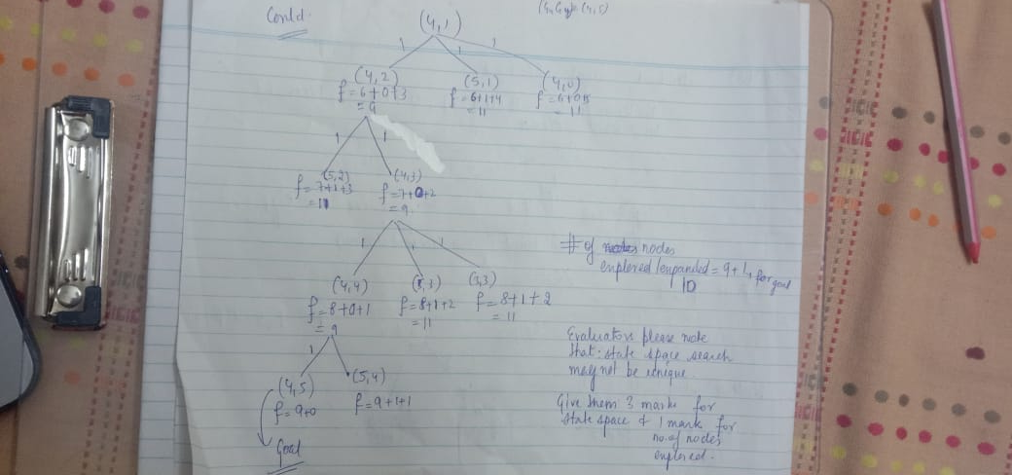

(3-c) Perform IDA* for the following graph C: START node, L=Goal. Show the steps. The number on the edge indicates the distance between two nodes. The numbers mentioned near the nodes are the heuristic values.



